**QUESTION NO 1:**

**AIM:**

To write a C program that accepts the word separated by space and then reverse the word.

**ALGORITHM:**

Step 1: Start the program by initializing the variable as char for string input, char rev for reversing the

Input.

Step 2: Get the sentence as input using fgets with str as variable, sizeof(srtr) as size and stdin for getting

Input.

Step 3: Assign the length of the string in a variable named length and do minus 1 for excluding null

Character.

Step 4: Using for loop iterate through the characters by its length .

Step 5: Using if condition include checking of null character, space and new line.

Step 6: Using another for loop initialize for j as size of first word(i) by minus one and condition as

J greater than or equal to prenum.

Step 7: Decrement the for loop for checking from back and using k as variable iterate rev variable using a

Array to move forward.

Step 8: Using another for loop with condition I less than k and increment I.

Step 9: Using the about for loop print the characters.

Step 10: Program has been ended with optional word count and character count.

**PROGRAM:**

#include<stdio.h>

#include<string.h>

int main()

{

    char str[100],rev[100],temp[100];

    int word=0,k=0,prenum=0;

    printf("Enter the sentence not more than 100 characters:\n");

    fgets(str,sizeof(str),stdin);

    int length=strlen(str)-1;

    printf("The length of character is:%d\n",length);

    for(int i=0;i<=length;i++)

    {

        if(str[i]==' ' || str[i] == '\0' || str[i] == '\n')

        {

            word++;

            for(int j=i-1;j>=prenum;j--)

            {

                rev[k]=str[j];

                k++;

            }

            prenum=i+1;

            rev[k++]=' ';

        }

    }

    printf("No of words:%d\n",word);

    for(int i=0;i<k;i++)

    {

        printf("%c",rev[i]);

    }

}

**OUTPUT**:

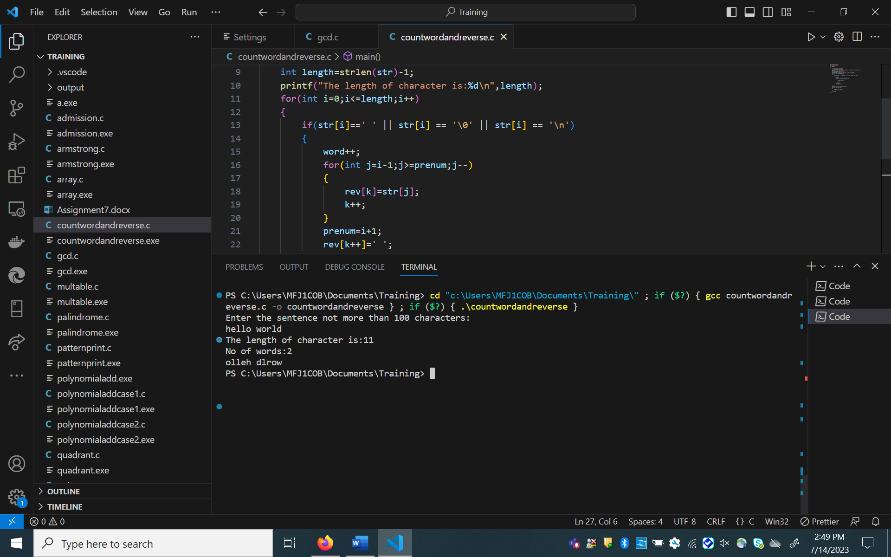

**Question 2:**

**AIM:**

To write a program that converts the string into ASCII value and again convert it to binary

Representation and the count the number of one’s in the program.

**ALGORITHM:**

Step 1: Start the program by initializing char as variable and get the string using fgets.

Step 2: Assign the length of the character in length.

Step 3: Using for loop iterate through the string except the null character.

Step 4: Declare a function named ConvertToBinary which accepts decimal as input.

Step 5: In the above function convert to binary by dividing by 2.

Step 6: Using for loop print the binary which is converted above .

Step 7: Declare another function named countOnes for counting the number of ones by taking

The modulo by 2 which is equal to 1 and increment the count.

Step 8: Using the for loop print all the character and its asked in details.

Step 9: The program has been executed with zero errors.

**PROGRAM:**

#include <stdio.h>

#include <string.h>

void convertToBinary(int decimal) {

    int binary[8];

    int i = 0;

    while (decimal > 0) {

        binary[i] = decimal % 2;

        decimal = decimal / 2;

        i++;

    }

    for (int j = i - 1; j >= 0; j--) {

        printf("%d", binary[j]);

    }

}

int countOnes(int decimal) {

    int count = 0;

    while (decimal > 0) {

        if (decimal % 2 == 1) {

            count++;

        }

        decimal = decimal / 2;

    }

    return count;

}

int main() {

    char str[100];

    printf("Enter a string: ");

    fgets(str, sizeof(str), stdin);

    int length = strlen(str);

    for (int i = 0; i < length-1; i++) {

        int ascii = (int)str[i];

        printf("Character: %c\n", str[i]);

        printf("ASCII value: %d\n", ascii);

        printf("Binary representation: ");

        convertToBinary(ascii);

        printf("\n");

        printf("Number of ones: %d\n", countOnes(ascii));

        printf("\n");

    }

    return 0;

}

**OUTPUT:**

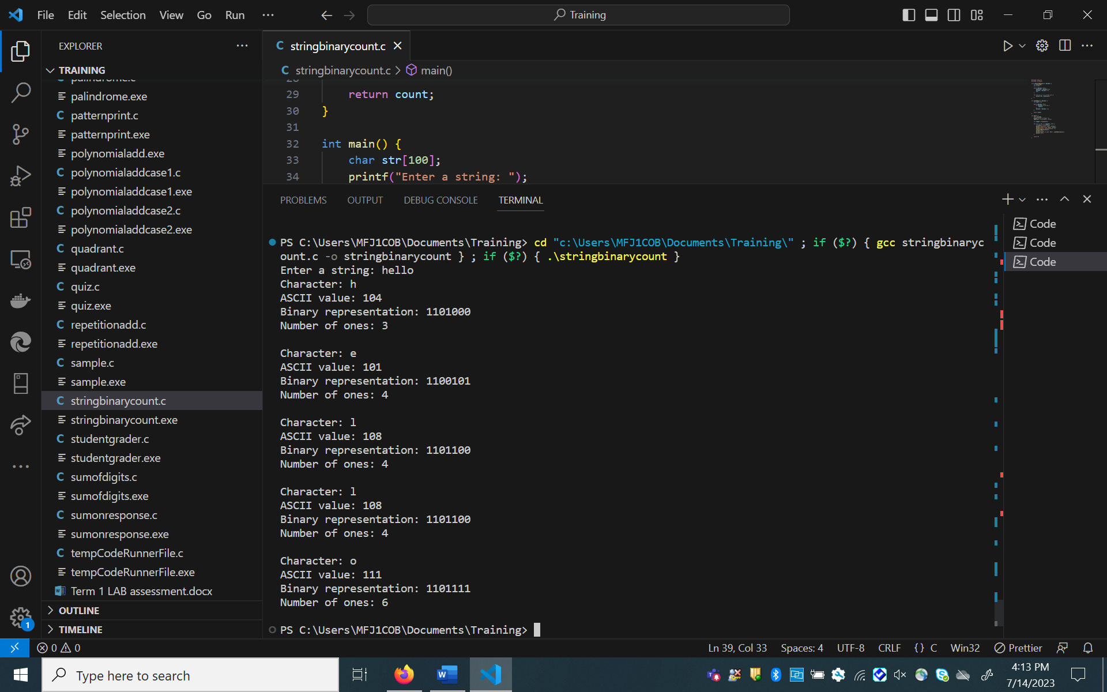

QUESTION 3:

**AIM:**

To write a C program to print Fibonacci number using recursion.

**ALGORITHM:**

Step 1: Start the program by initializing the variable as num which represents the frequency of

Fibonacci.

Step 2: Using for loop iterate through the num and print the result by giving the I value as

Input for the fibonaccinumber function .

Step 3: In fibonaccinumber function initialize the variable a as 0 and b as 1.

Step 4: If the num is equal to 0 return a.

Step 5: Else if num is equal to 1 return b.

Step 6: Else execute the function as recursion with condition fibanaccinumber(num – 1) +

fibanaccinumber(num-2).

Step 7: End the program the printing the result.

**PROGRAM:**

#include<stdio.h>

int fibonaccinumber(int num)

{

    int a=0,b=1;

    if(num==0)

    {

        return a;

    }

    else if(num==1)

    {

        return b;

    }

    else

    {

        return (fibonaccinumber(num-1) + fibonaccinumber(num-2));

    }

}

int main()

{

    int num;

    printf("Enter the number:\n");

    scanf("%d",&num);

    printf("---------------------------------------\n");

    printf("Result: \n");

    for(int j=0;j<num;j++)

    {

        printf("%d ",fibonaccinumber(j));

    }

    printf("\n");

    printf("---------------------------------------\n");

    return 0;

}

**OUTPUT:**

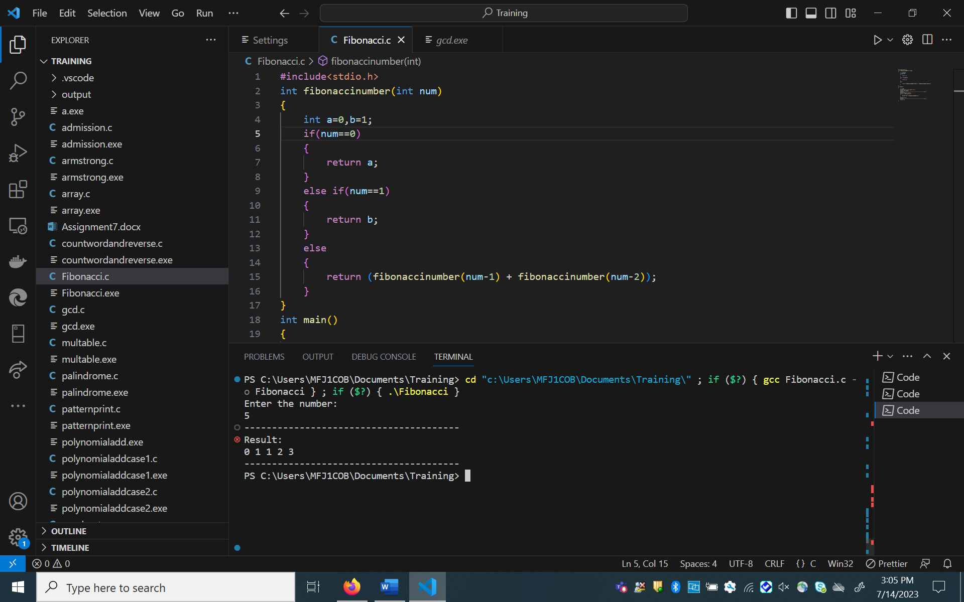

**QUESTION 4:**

**AIM:**

To write a C program to print the matrix multiplication using multidimensional array.

**ALGORITHM:**

Step 1: Start the program with defining max_size as 100 in macro.

Step 2: Declare a function named matrixmultiplication which accepts array one, two, result and

Row and column as input.

Step 3: With for loop I increment through row and using inner for loop increment through

Column and another for loop k for multiplying the array’s row with array’s two column.

Step 4: Declare another function named PrintMatrix with arguments as matrix, row and

Column.

Step 5: With outer as I and inner loop as j iterate through row and column respectively and

Print the results.

Step 6: In the main function get the input from the user for rows and columns.

Step 7: Using for loop as in step 5 get the input from the user as array one and array two.

Step 8: Pass the value the values for the matrixmultiplication function and do the calculations.

Step 9: Now again pass the values for printmatrix function.

Step 10: The program has been executed successfully with 0 errors.

**PROGRAM:**

#include <stdio.h>

#define MAX_SIZE 100

void matrixMultiplication(int arr1[][MAX_SIZE], int arr2[][MAX_SIZE], int res[][MAX_SIZE], int row, int col) {

    int i, j, k;

    for (i = 0; i < row; i++) {

        for (j = 0; j < col; j++) {

            res[i][j] = 0;

            for (k = 0; k < col; k++) {

                res[i][j] += arr1[i][k] * arr2[k][j];

            }

        }

    }

}

void printMatrix(int matrix[][MAX_SIZE], int row, int col) {

    int i, j;

    for (i = 0; i < row; i++) {

        for (j = 0; j < col; j++) {

            printf("%d\t", matrix[i][j]);

        }

        printf("\n");

    }

}

int main() {

    int arr1[MAX_SIZE][MAX_SIZE], arr2[MAX_SIZE][MAX_SIZE], res[MAX_SIZE][MAX_SIZE];

    int i, j, row, col;

    printf("MATRIX MULTIPLICATION:\n");

    printf("Enter the number of rows: ");

    scanf("%d", &row);

    printf("Enter the number of columns: ");

    scanf("%d", &col);

    printf("Enter the values for the first matrix:\n");

    for (i = 0; i < row; i++) {

        for (j = 0; j < col; j++) {

            scanf("%d", &arr1[i][j]);

        }

    }

    printf("Enter the values for the second matrix:\n");

    for (i = 0; i < row; i++) {

        for (j = 0; j < col; j++) {

            scanf("%d", &arr2[i][j]);

        }

    }

    matrixMultiplication(arr1, arr2, res, row, col);

    printf("The result of matrix multiplication is:\n");

    printMatrix(res, row, col);

    return 0;

}

**OUTPUT:**

